# SAP Essentials

In order to do stable SAP automations – there are a few things to consider…

**Requirements**

* SAP GUI installed & configured
* After you have installed the SAP GUI Client you need to enable scripting and check Help Settings of the SAP User you want to run the Demo with.
* [See here](https://docs.uipath.com/studio/v2020.4/docs/sap-configuration-steps#section-enabling-sap-gui-scripting) how to enable scripting (Server **\*and\*** Client side)
* [See here](https://docs.uipath.com/studio/v2020.4/docs/sap-configuration-steps#section-enabling-modal-dialog-boxes) how to enable Modal Settings in Help (Server-side user context)
* [See here](https://docs.uipath.com/studio/v2020.4/docs/sap-configuration-steps#section-enabling-high-speed-connections) to check if you have enabled High Speed Connection

## Configure the user in SAP for Automation (apart from scripting)

1. **Ensure after Log-On to change HELP**

Select on the main menu *“More > Help > Settings*” and then select:  
*F1-HELP*: “in modal dialog box”  
*F4-HELP*: “dialog modal”

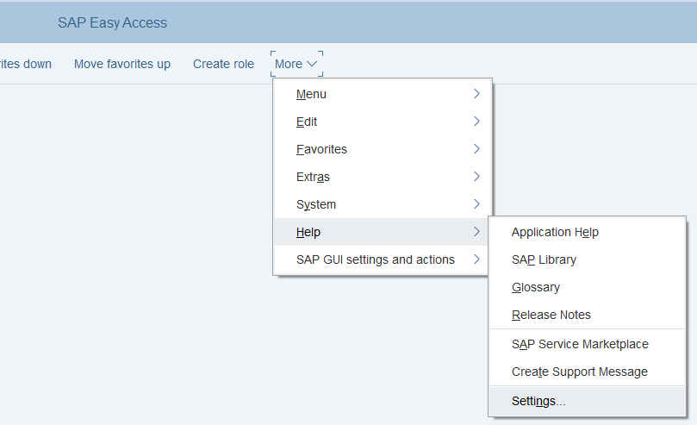

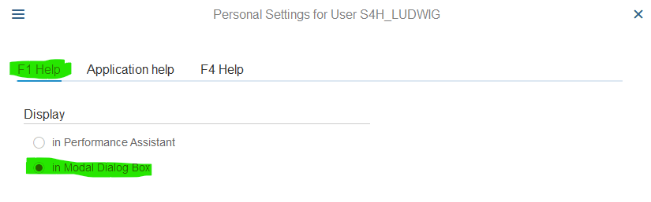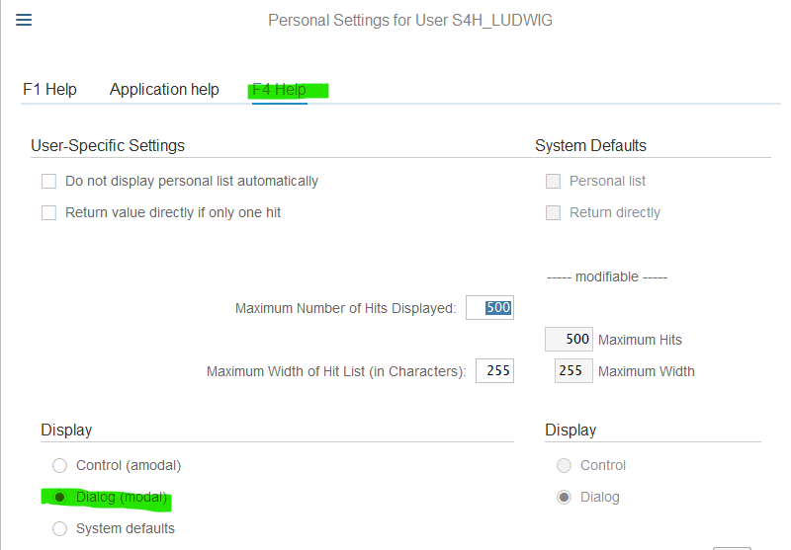

## Creating your own SAP User

If you have a demo environment, you may want to create a copy of an existing user

1. **Logon to SAP as one of the demo users**

Enter transaction code (TCODE) **SU01**  
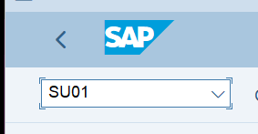

1. **Copy an existing user**

Click on “**Copy**” or use keyboard shortcut “Shift+F5”  
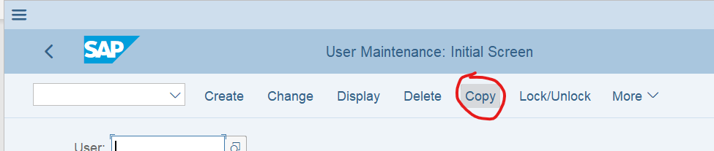

1. **Enter source user-id and new user-id and click on “Copy”**

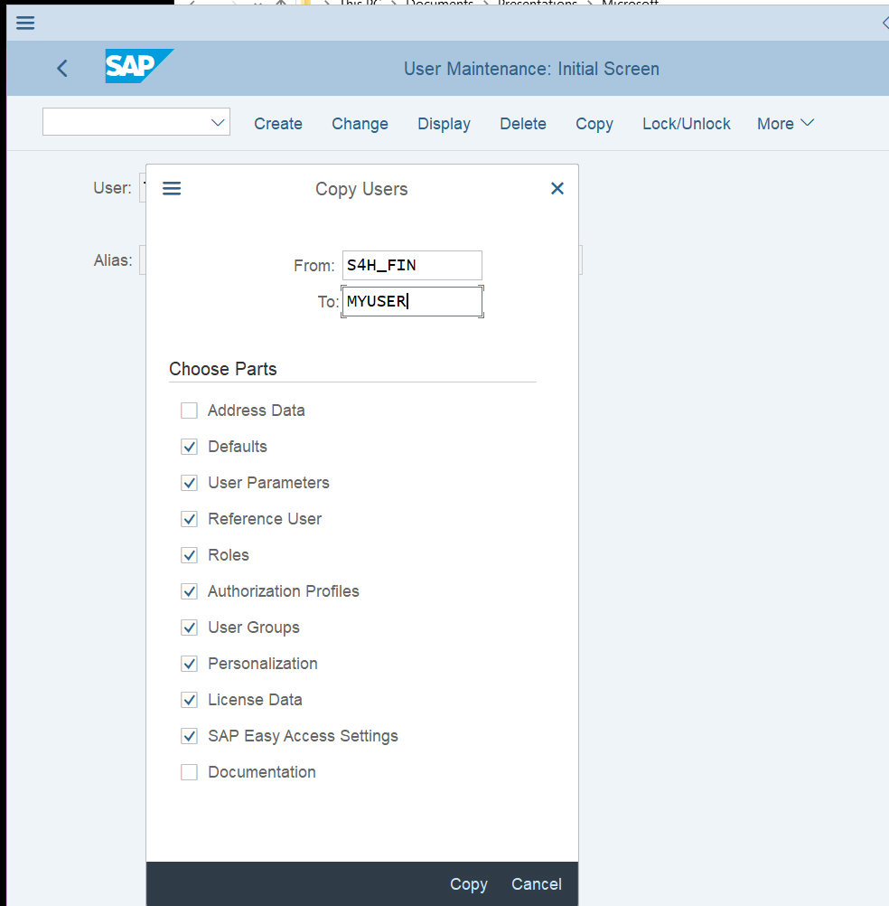

1. **Add default Company (BUK) for transactions**

Select the tab Parameters and add a new line to the parameters table. Parameter ID = BUK.

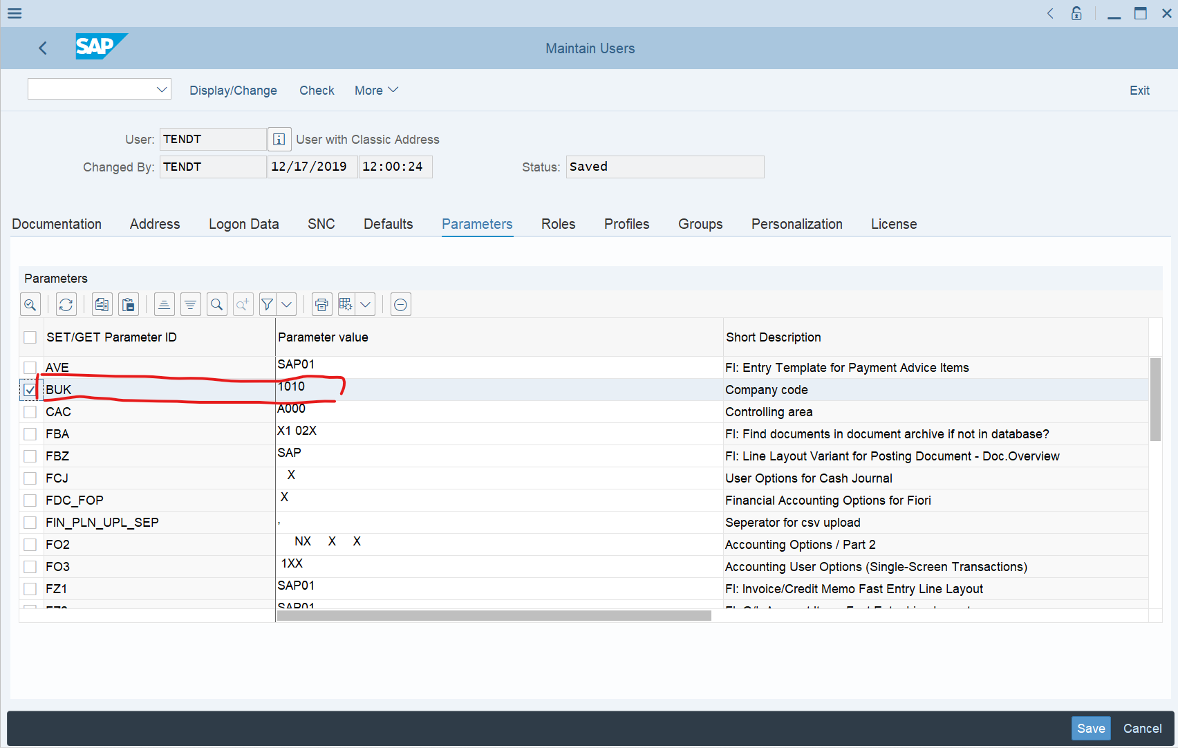

1. **Set your initial Password**

Select the tab “Logon data” and provide the initial Password. If you have a default Password for running the flow later in mind, do *not* enter now, as with the first Logon you need to change it again.

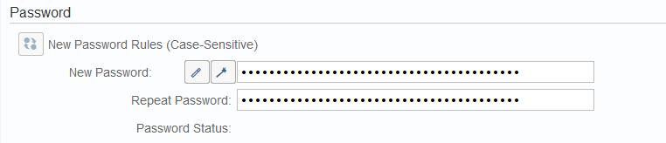

1. **Logoff from current and first Logon with your new User**

When you Logon the first time, you need to change your initial Password. The once logged on, you need to adjust one more thing

1. **First time with your new user logged on – Change HELP**

Select on the main menu “More > Help > Settings” and then select:  
F1-HELP: “in modal dialog box”  
F4-HELP: “dialog modal”



